

FRONT END – PART 1
MAJOR PROJECT - 1

(Web Development CSS Major Project)

Single Playlist Screen
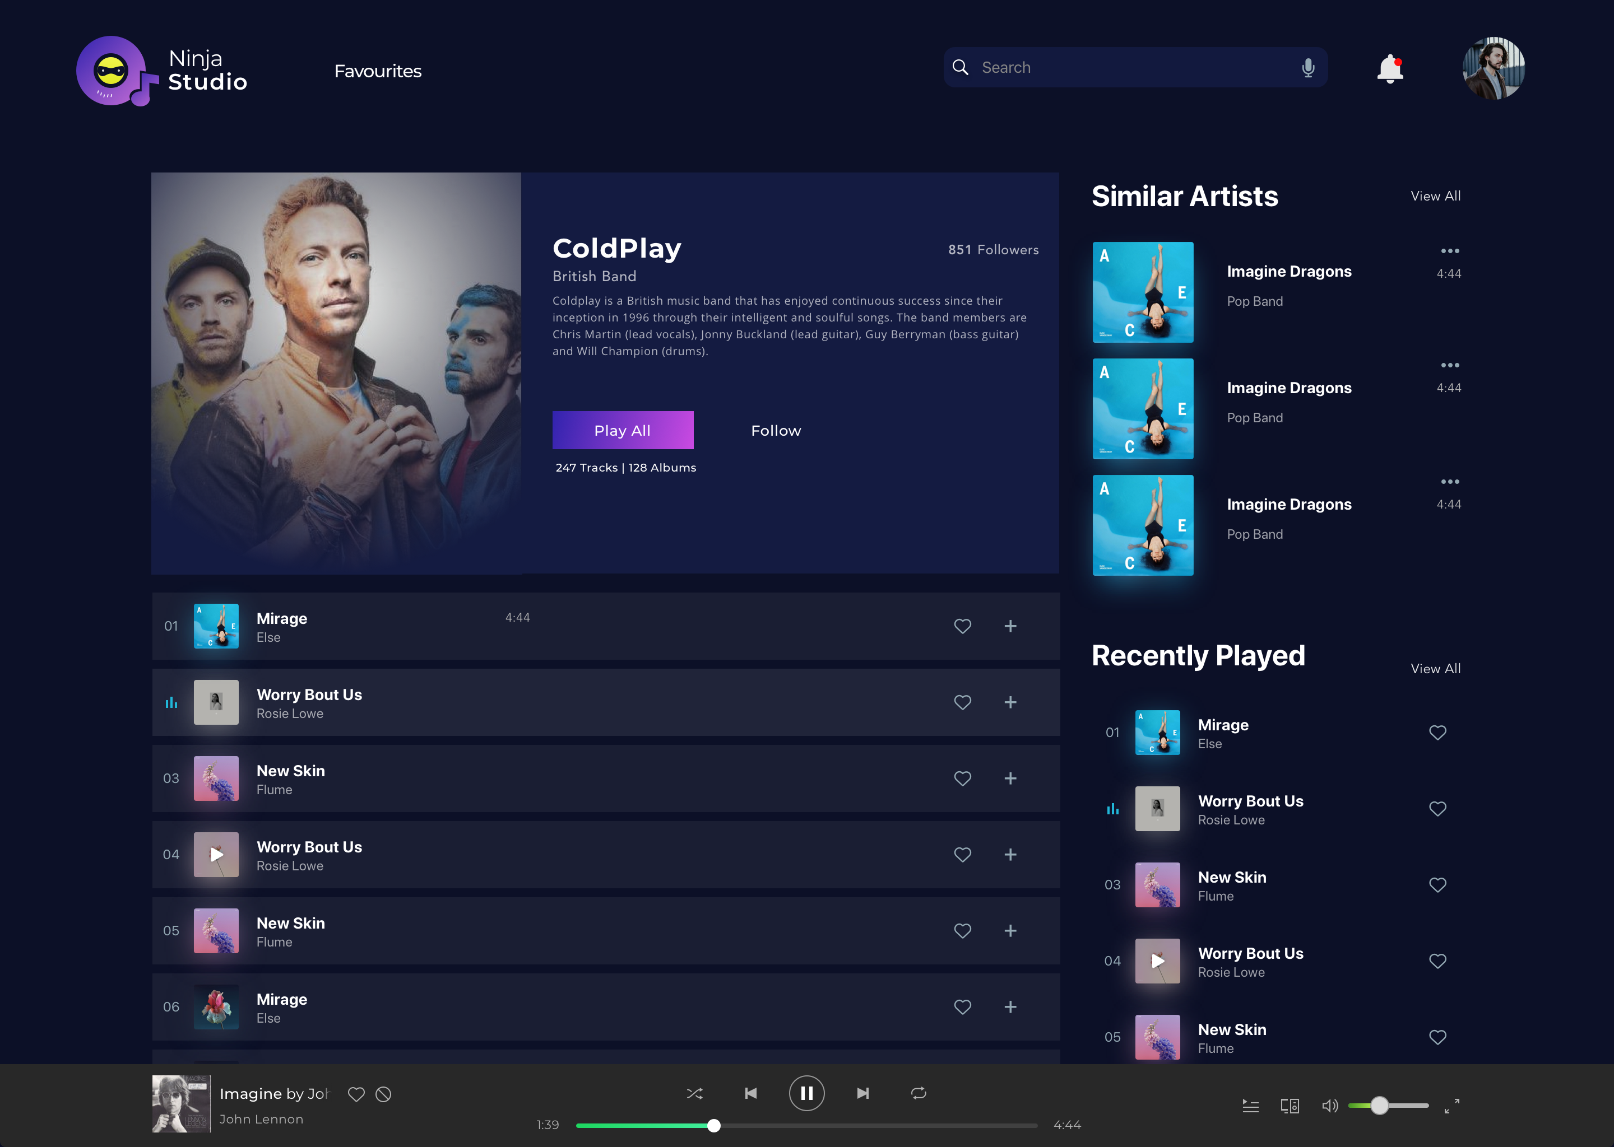
Remember that there are more than one ways to build a web page, so don't hesitate to try things on your own and explore new things online if you get stuck anywhere. That will help you to enhance your knowledge.
Take care of following points -

1. Home Screen Carousel - Try creating home screen carousel using CSS. For now it will be with dummy images, but ensure the functionality.

2. Code Quality - Ensure good code quality in terms of using classes, proper names for classes/variables, neatness of code and less redundant code.

3. Comments - You should add proper comments to the files, where you feel. This will improve readability of your code and will also help Teaching Assistants to understand it better.

4. Innovation - Although you are given basic template, feel free to explore more and add interesting features to your Music Player. You can also try different themes for the player(CSS Variables will help!)

Once you complete and submit your project, you will be scored according to the parameters provided below.
Your project will be evaluated on following parameters -

HOME SCREEN (Max Score 20)
Each section should be implemented in its entirety as explained through the images provided, avoid misalignments and overflows.

ASIDE QUEUE (Max Score 6)
Should be implemented in its entirety as explained in images provided.

CODE QUALITY AND COMMENTS (Max Score 22)
Ensure proper structuring your webpage, Code Optimization, Code Readability, Proper Commenting. Avoid plagiarism.

SINGLE PLAYLIST SCREEN (Max Score 12)
Each section of should be implemented in its entirety as explained through the images provided, avoid misalignments and overflows.

RESPONSIVITY (Max Score 10)
Website should not break in any kind of view.

HOME SCREEN CAROUSEL (Max Score 10)
Should be properly functional.

BOTTOM MUSIC PLAYER (Max Score 10)
Should be properly functional and innovative.

INNOVATION (Max Score 10)
Although you are given basic template, feel free to explore more and add interesting features to your Music Player. You can also try different themes for the player.

**********

